**Chat App**

**Authentication**

**Login  
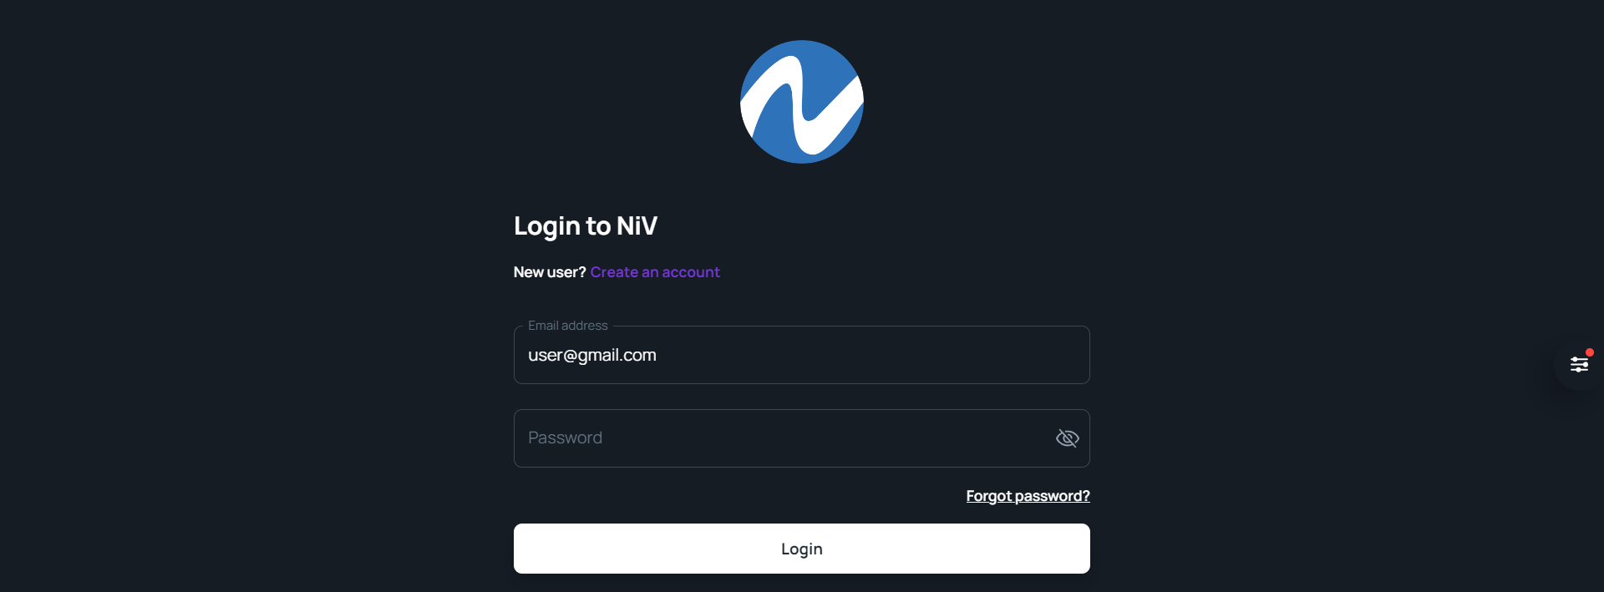  
Register  
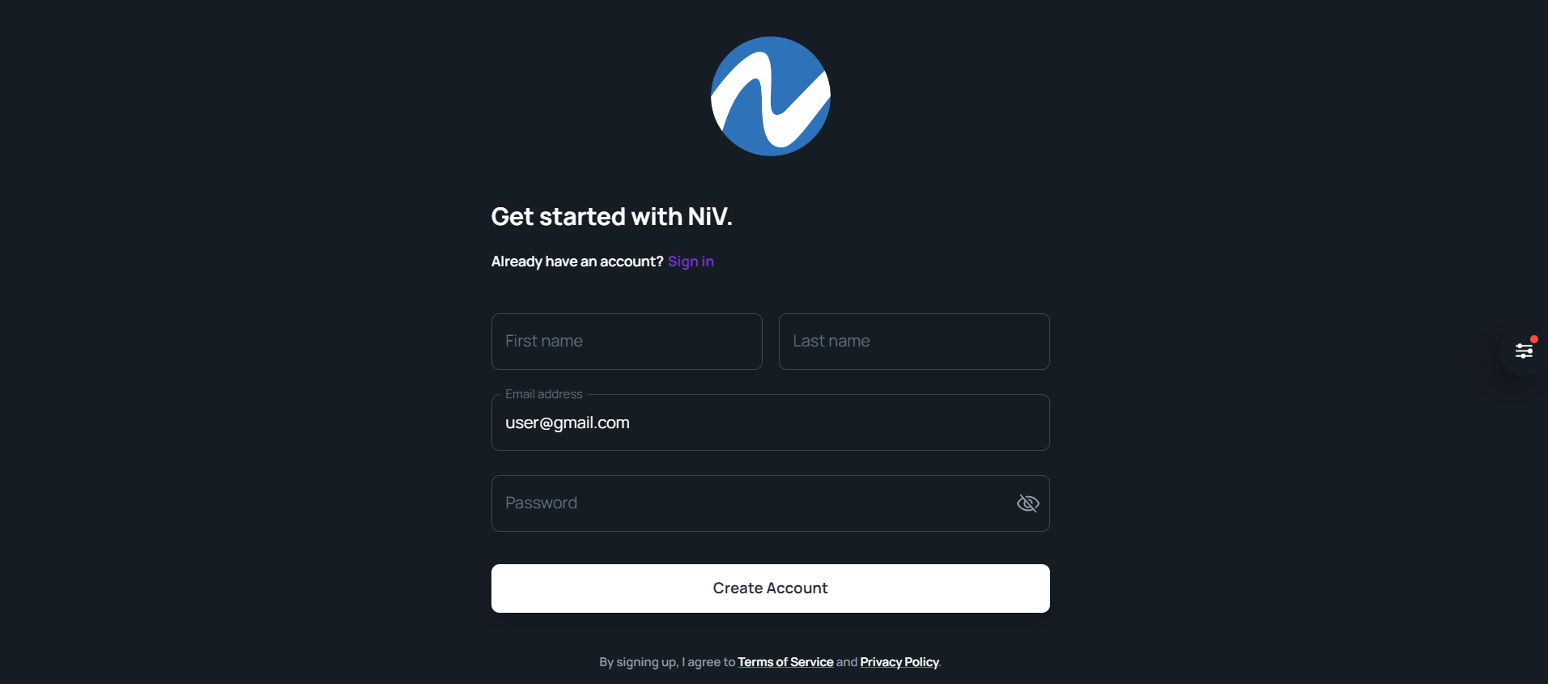**

  
**Forgot password**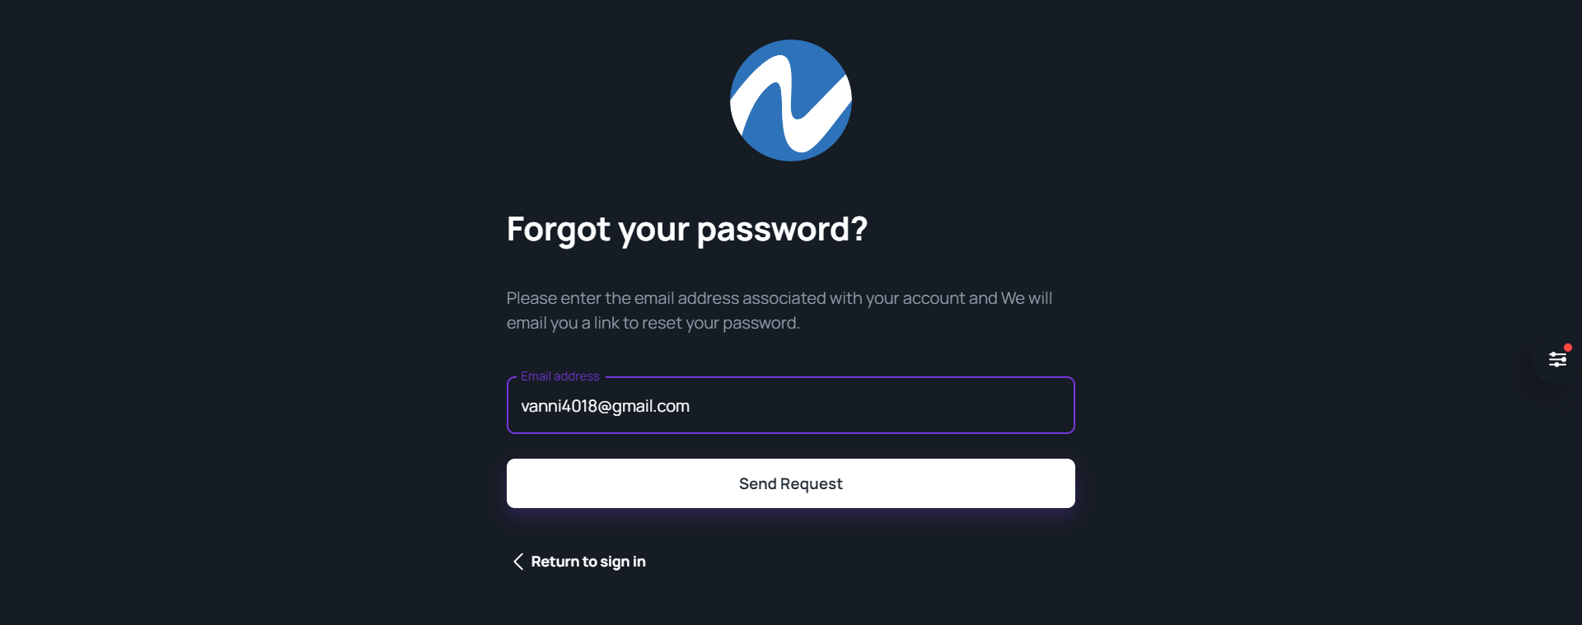  
  
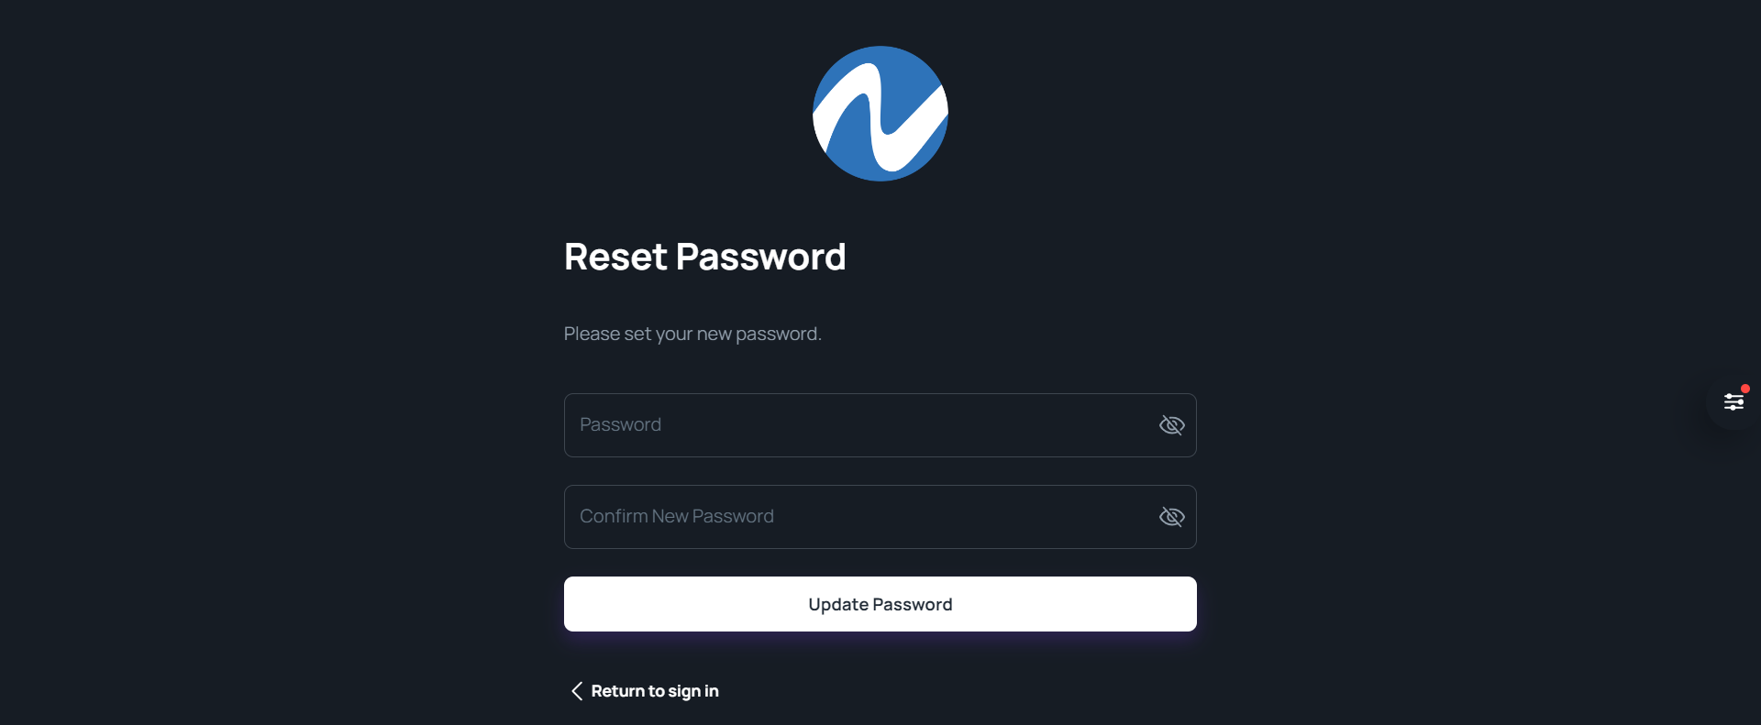  
  
**One-to-one chat**  
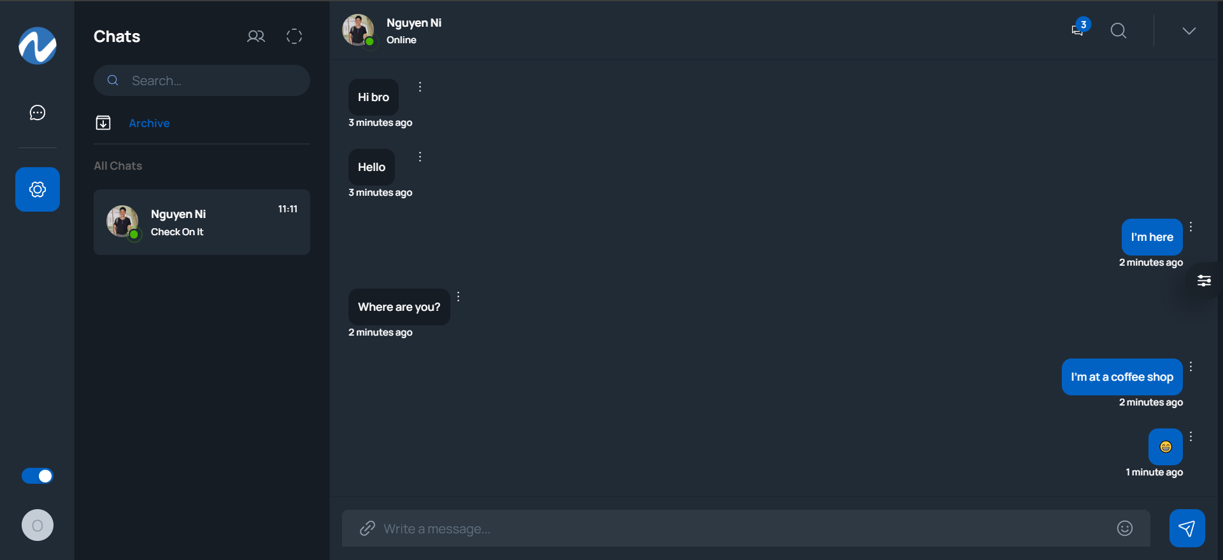  
  
**Some features:**⚛️ Tech Stack: React.js, MongoDB, Node.js, Express.

🔐 Authentication with JSONWEBTOKENS (JWT)

🔥 Friend requests, accept a friend

👥 One to one chat

🌐 Deployment

⏳ And much more!

**Start the app**

npm install

npm start